

**FACULTY OF INFORMATICS**

**COURSEWORK COVERSHEET**

|  |  |  |  |
| --- | --- | --- | --- |
| **SUBJECT’S INFORMATION:** | | | |
| Subject: | CSCI368 Network Security | | |
| Session: | February 2020 | | |
| Programme / Section: | BCS | | |
| Lecturer: | **Mohamad Faizal Alias** | | |
| Coursework Type  *(tick appropriate box)* | ❑ Individual Assessment | | |
| Coursework Title: | Assessment 1 | Coursework Percentage: | 10% |
| Hand-out Date: | Week 3 | Received By :  (signature) |  |
| Due Date: | Week 6 | Received Date : |  |
| **STUDENT’S INFORMATION:** | | | |
| Student’s Name & ID: | **6306196** |  |  |
| Contact Number / Email: | **TEH WIN SAM / me@tehwinsam.com** |  |  |
| **STUDENT’S DECLARATION** | | | |
| By signing this, I / We declare that:   1. This assignment meets all the requirements for the subject as detailed in the relevant Subject Outline, which I/ we have read. 2. It is my / our own work and I / we did not collaborate with or copy from others. 3. I / we have read and understand my responsibilities under the University of Wollongong’s policy on plagiarism. 4. I / we have not plagiarised from published work (including the internet). Where I have used the work from others, I / we have referenced it in the text and provided a reference list at the end of the assignment.   I am / we are aware that late submission without an authorised extension from the subject co-ordinator may incur a penalty. *(See your subject outline for further information).* | | | |
| Name & Signature: | TEH WIN SAM |  |  |

------------✂ -------------------✂ ------------------✂ -------------------✂ --------------------✂ ---------------------✂ --

|  |  |  |  |  |
| --- | --- | --- | --- | --- |
| Subject: | CSCI368 Network Security | | Session: | February 2020 |
| Programme / Section: | BCS | | Lecturer: | **Mohamad Faizal Alias** |
| Coursework Type:  (Tick appropriate box) | ❑ Individual Assessment | | | |
| Coursework Title: | Assessment 1 | Coursework Percentage: | | 10% |
| Hand-out Date: | Week 3 | Received By:  (Signature) | |  |
| Due date: | Week 6 | Received Date: | |  |
| **STUDENT’S INFORMATION:** | | | | |
| Student’s Name & ID: | 6306196 |  | |  |
| Contact Number / Email: | TEHWINSAM  013-369-6298 |  | |  |

**COURSEWORK SUBMISSION RECEIPT**

|  |  |  |  |
| --- | --- | --- | --- |
| **Assessment Criteria** | | **Total Marks** | **Given Marks** |
|  | **Part 1:** |  |  |
|  | Quiz 1 | 2 |  |
|  |  |  |  |
|  | **Part 2:** |  |  |
|  | Modified DH key exchange protocol and the shared key computations | 3 |  |
|  | AES Encryption and RSA PKC | 3 |  |
|  | CFB - Mode of Block Cipher | 1 |  |
|  | Presentation of work product | 1 |  |
|  | | **10** |  |
|  | | **Penalty** |  |
| Marked by: _____________________ Date: ________ | | **Final Mark (10 %)** |  |
| **Lecturer’s Comments** | | | |
|  | | | |
| **Penalty for late submission:** | | | |
| 1 day – minus 20% of total mark awarded  2 days – minus 50% of total mark awarded  3 days – 0 mark for this piece of coursework | | | |

**University of Wollongong**

**CSCI368 NETWORK SECURITY**

**February 2020**

**Individual Assessment 1 (10 %)**

**Aims**

This assignment consists of two parts. Part 1 is a Quiz 1 that focuses on revision aspects of Computer Network concepts learnt in the earlier semester. This is to build-up a good foundation before further topics on Network Security are covered.

Part 2 of this assessment aims to establish a basic familiarity with the cryptographic methods and provides an exercise of key establishment and secure communication in a networked environment.

**Objectives**

On completion of this assignment you should be able to:

* Understand some basic concepts in cryptography and networking
* Understand key transport and secure communication.
* Understand network programming.
* Applying AES and Key Exchange concepts.

**Part 1 – Quiz 1**

**Online Quiz 1 – Computer Networks Revisited**

* The quiz consists of 10 MCQs each. You are given only 20 minutes to complete the quiz. Refer to Blended Learning Plan on Moodle.

**Part 2 – Key Exchange Program Development**:

**Specifications**

Write C++ UDP or TCP programs allowing two parties to establish a secure communication channel. For simplicity, let us call the programs “Host” and “Client”; each can be used by a user. Again, for simplicity, let us assume that Alice uses Host and Bob uses Client.

Alice and Bob want to establish a secure communication channel where messages are encrypted with **AES encryption** in which operates on **128-bit blocks** using a **192-bit key**.

The **key establishment** is done by using modified Diffie-Hellman Exchange scheme (modified for this assignment). Alice has a pair of private/public keys (x1, y1) and Bob has a pair of private/public keys (x2, y2), generated by your program via **KeyGen**. By key exchange, they obtain a share secret key, which is a **192 bit AES session key.** The PKC that handles both public key and private key should be **RSA**.

Place Host and Client in two separate directories: Alice and Bob. Alice’s keys are stored in a file located at her directory (Alice) and Bob’s keys are stored in a file located at his directory (Bob).

The protocol is described as follows:

1. Alice runs **KeyGen** to generate a pair of her private and public keys including all required parameters based on **RSA** requirements. These keys and parameters are stored in directory Alice.
2. Bob runs **KeyGen** to generate a pair of his private and public keys including all required parameters based on **RSA** requirements. These keys and parameters are stored in directory Bob.
3. Alice executes Host.
   1. Host is running and listening to the opened port (you need select a port for your code).
   2. Preferable that the moment the user execute Host program, the program will ask the user to setup the IP and a port number.
4. Bob executes Client.
   1. Preferable that the moment the user execute Client program, the program will ask the user identify the IP and a port number to connect to (which is the Host executed earlier)
   2. Client (Bob) sends his **public key y2** to Host (Alice) together with Hash of this key in SHA-1 format.
   3. Client is ready and listens to the port for next response.
5. Upon receiving the public key and SHA-1 hash from Bob, Alice first verify the integrity of the Public key. Alice then send a “Verified” message to Bob.
6. Alice then computes/generates the **192 bit AES session key and SHA-1 hash of this session key**. This session key is unique for each runs of the program.
7. Alice sends **her public key y1 + SHA-1 hash** to Bob (Client) – expose. Then she send **encrypted 192 bit AES session key + SHA-1 hash** with **Bob Public Key y2**.
8. Bob received the above components. He verify Alice public key y1 with the SHA-1 hash.
9. Then Bob decrypt the encrypted components of 192 bit AES session key + SHA-1 hash using **his Private Key x2**.
10. As for confirmation of receiving the session key, Bob encrypt back a message of “Acknowledge” with the **192 bit AES session key** and send back to Alice. (note: only when step 8 and 9 above are verified with their respective Hash).
11. Upon receiving the encrypted message, Alice Decrypt it (using **her local copy of 192 bit AES session key).** If the message represent **“Acknowledge”** she knows that the secure communication now can take place. If match, Alice send a signal message “Ready” encrypted using the AES session key to Bob.
12. Once the message “Ready” sent to Bob, **Alice reverse the 192 bit AES key** to be use for the next secured communication.
13. Bob, upon receiving this Encrypted message “Ready”, he decrypts it and identifies this signal. With this, Bob now, **reverse the 192 bit AES key**.
14. Now, the secure channel is established.
    1. Either Alice or Bob can send a message encrypted with the **reverse** **192 bit AES session key** (from the original key) now. They type the message on their own terminal. The message is encrypted by the program (Host or Client) and sent out.
    2. All message must use **Cipher Feed Back Mode (CFB) mode of block Cipher**.
    3. The received encrypted message and decrypted message are displayed on the screen.
    4. Either one Host or Client can quit the program by using “exit”.

**Questions:**

Attempt these questions either by answering it in your report or directly implement in your code.

What happen if acknowledgment messages such as “verified”, acknowledge” and “ready” never arrives or corrupted during transmission?

What happen if connection is terminated half-way?

How to ensure the program continue running and “catch” this error?

Suggest the best way to tackle the above problem. (**Note**: there are multiple strategies or combination of strategies for the above questions)

**Note:**

For presentation/demo purposes, each steps of generating Private, Public key by RSA, the 192 bit AES session key, The matching process for acknowledgement and the reverse of 192 bit AES session key should be displayed on your terminal. This is to verify that your client and server program conform with all the requirements stated above.

**Coding requirement:**

You need to write (or re-use from library) four functions:

1. KeyGen for RSA Public/Private keys
2. **192 bit AES session key** generation.
3. **Reversing process of 192 bit session key.**
4. **AES** encryption/Decryption using **reverse of 192 bit AES session key** for secure communication.
5. **CFB mode**
6. Host.
7. Client.

**How to run during presentation?**

Your programs should run according to the protocol mentioned above. Host and Client should be executed on different computers. You need a pair of computers. I suggested that you execute the Host program, and the Client program on your friend’s computer (or computer available in the lab – if required). For simplicity, there is no GUI required in this assignment. That is, messages are simply typed on the terminal and printed on the receiver’s terminal.

Remember, during secure communication between Alice and Bob, displayed text message should be as a pair, Encrypted message and the decrypted message. The looping should continue until the moment the user chooses to exit with some sort of termination command.

Presentation day and slot will be announced by your lecturer.

**Submission:**

* Part 1 – Both Quiz 1 is on-the-spot quizzes during Blended Hours.
* Part 2 – Submission is on or before the end of Week 7 via Submission link on Moodle

**Part 2 Submission requirements:**

You are required to prepare a report on your program development (part 2), the execution (with screen captures) and simple testing done. The softcopy of the report together with the program (source files) are required to be in a Zipped folder.

**Plagiarism**

A plagiarised assignment will receive a zero mark (and penalised according to the university rules). Plagiarism detection software will be used.

Contents

Alice executes Host. 8

Alice runs **KeyGen** to generate a pair of her private and public keys including all required parameters based on **RSA** requirements. These keys and parameters are stored in directory Alice. 8

Bob executes Client. 11

Bob runs **KeyGen** to generate a pair of his private and public keys including all required parameters based on **RSA** requirements. These keys and parameters are stored in directory Bob. 11

Upon receiving the public key and SHA-1 hash from Bob, Alice first verify the integrity of the Public key. Alice then send a “Verified” message to Bob. 15

Alice then computes/generates the **192 bit AES session key and SHA-1 hash of this session key**. This session key is unique for each runs of the program. 17

Alice sends her public key y1 + SHA-1 hash to Bob (Client) – expose. Then she send encrypted 192 bit AES session key + SHA-1 hash with Bob Public Key y2. 18

Bob received the above components. He verify Alice public key y1 with the SHA-1 hash. 20

Then Bob decrypt the encrypted components of 192 bit AES session key + SHA-1 hash using **his Private Key x2**. 21

As for confirmation of receiving the session key, Bob encrypt back a message of “Acknowledge” with the **192 bit AES session key** and send back to Alice. (note: only when step 8 and 9 above are verified with their respective Hash). 23

Upon receiving the encrypted message, Alice Decrypt it (using **her local copy of 192 bit AES session key).** If the message represent **“Acknowledge”** she knows that the secure communication now can take place. If match, Alice send a signal message “Ready” encrypted using the AES session key to Bob. 25

Once the message “Ready” sent to Bob, Alice reverse the 192 bit AES key to be use for the next secured communication. 30

Bob, upon receiving this Encrypted message “Ready”, he decrypts it and identifies this signal. With this, Bob now, reverse the 192 bit AES key. 32

Now, the secure channel is established. 33

Either Alice or Bob can send a message encrypted with the **reverse** **192 bit AES session key** (from the original key) now. They type the message on their own terminal. The message is encrypted by the program (Host or Client) and sent out. 33

All message must use Cipher Feed Back Mode (CFB) mode of block Cipher. 33

The received encrypted message and decrypted message are displayed on the screen. 33

Either one Host or Client can quit the program by using “exit”. 33

**USER MANUAL (GITHUB)** 36

README.MD 36

GIT CLONE FROM GITHUB 36

INSTALLATION 36

COMMAND TO COMPILE/BUILD 36

ADD PRIVILEGE TO THE BINARY FILE 36

**Extra Miles**

Attempt these questions either by answering it in your report or directly implement in your code.  
What happen if acknowledgment messages such as “verified”, acknowledge” and “ready” never arrives or corrupted during transmission?  
What happen if connection is terminated half-way?  
How to ensure the program continue running and “catch” this error?  
Suggest the best way to tackle the above problem. (**Note**: there are multiple strategies or combination of strategies for the above questions)

My recommendation is that if “Ready” or “Acknowledge” never arrives, in probably 30-64 seconds the program will quit or decide to restart the handshake process starting from KeyGen(). Definitely terminal the program will be the best option, we never knew how attacker can think out of box  
But what if Acknowledge or Verified are ‘corrupted during transmission’, in my program after Server or Client have successfully decrypted the AES key and AES IV. Client will send ‘Acknowledge text’ in Encrypted format to recipient but I prefer to increase the complexity with certain algorithm probably we make use of *timetamp + username + destination port + some public key elements + Ready or Acknowledge text* concatenate and generate into a ‘SHA1 digest == 40 lengths long’ so that it make Attack difficult to ‘CRAFT’ the message, since hash is a one-way encryption algorithm. Attackers run at a blackbox meaning attackers have no prior knowledge about the source code. In other word, attackers doesn’t know how the ‘HASH’ are being made.

If any connection is terminated half-way, program will required to restart the process starting from ‘listening on a port’ and ‘connect to a port’. We never know what can be done by attackers, if you heard about ‘Socket Reuse’ that attacker can reuse back the socket to start his own ‘taking’ .

To catch the program, there definitely a ‘try and catch’ function. Mainly start from received buffer, let say we know that SHA1 length always 40, if we received 39 lengths but not 40 lengths. Program will be terminate, because the ‘content’ might have intercept by someone else.

Alice representing Server

Bob representing Client

# Alice executes Host.

## Alice runs **KeyGen** to generate a pair of her private and public keys including all required parameters based on **RSA** requirements. These keys and parameters are stored in directory Alice.

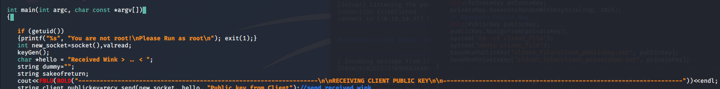

At the very first beginning of my server.cpp it will check is the program is running as root or not, if it’s not running as root privilege the program will quit.

After finished verify the root access, we will start to run ‘port binding’ which will allow client to connect our server.

Code below is to “start a server listening on a ‘specific’ port”. In our scenario we will be listening on port ‘4444’.

Lastly, keygen(), which will allow us to generate our ‘unique KEY PAIR‘. Then we will do some display and declare some variable for future.

int socket()

{

do{

cout<<"Enter port number to start the listener"<<endl;

cin >> PORT;

if(PORT > 65535 || PORT <1)

{

cout<<"are you dumb ? the port range is \"1 - 65535\" "<<endl;

}

}while(PORT > 65535 || PORT < 1);

printf ("[Server] Listening the port %d successfully.\n", PORT);

int server_fd, new_socket, valread;

struct sockaddr_in address,peer_addr;

int opt = 1;

int addrlen = sizeof(address);

// Creating socket file descriptor

if ((server_fd = socket(AF_INET, SOCK_STREAM, 0)) == 0)

{

perror("socket failed");

exit(EXIT_FAILURE);

}

// Forcefully attaching socket to the port 8080

if (setsockopt(server_fd, SOL_SOCKET, SO_REUSEADDR | SO_REUSEPORT,

&opt, sizeof(opt)))

{

perror("setsockopt");

exit(EXIT_FAILURE);

}

address.sin_family = AF_INET;

address.sin_addr.s_addr = INADDR_ANY;

address.sin_port = htons( PORT );

// Forcefully attaching socket to the port 8080

if (bind(server_fd, (struct sockaddr *)&address,

sizeof(address))<0)

{

perror("bind failed");

exit(EXIT_FAILURE);

}

if (listen(server_fd, 3) < 0)

{

perror("listen");

exit(EXIT_FAILURE);

}

if ((new_socket = accept(server_fd, (struct sockaddr *)&address,

(socklen_t*)&addrlen))<0)

{

perror("accept");

exit(EXIT_FAILURE);

}

char *ip;

printf("Connection Established\n");

char host[NI_MAXHOST]; // Client's remote name

char service[NI_MAXSERV]; // Service (i.e. port) the client is connect on

memset(host, 0, NI_MAXHOST); // same as memset(host, 0, NI_MAXHOST);

memset(service, 0, NI_MAXSERV);

if (getnameinfo((sockaddr*)&address, sizeof(address), host, NI_MAXHOST, service, NI_MAXSERV, 0) == 0)

{

string ls = GetStdoutFromCommand("ifconfig eth0 | grep -w inet | awk '{ print $2}'");

int a =ls.length();

std::string str2 = ls.substr (0,a-1); // "think"

cout <<"connect to ["<<str2 <<"] from (UNKNOWN) ["<<host<<"] "<< service << endl;

}

return new_socket ;

}

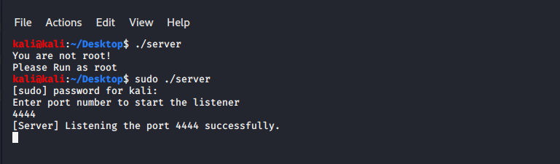

Void keygen()

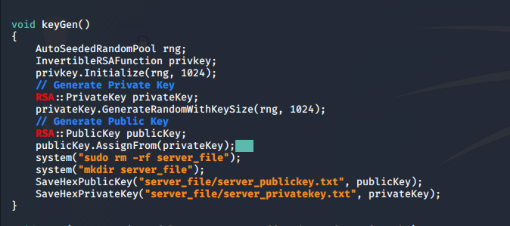

We create 1024 bits of public key, we ran *sudo rm-rf server_file* to clean the directory and sub-directory. Next will run

*mkdir server_file* to create our “server_file” directory which will store our *publicKey* and *privateKey.*

Code below is code relating how we store our data from *raw* into *HexMessages* and store into *.txt* file.

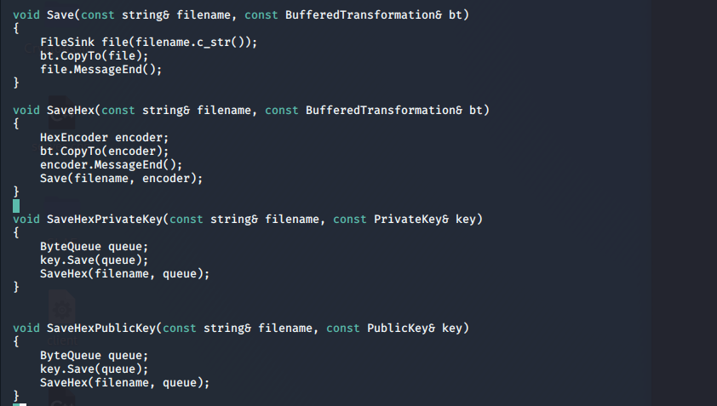

# Bob executes Client.

## Bob runs **KeyGen** to generate a pair of his private and public keys including all required parameters based on **RSA** requirements. These keys and parameters are stored in directory Bob.

From client perspective, we declare some variables that related to ‘listening buffer/messages from server’. Next after finished generating the key, the Client’s *publickey* and *privatekey* are stored in *client_file.* Then it will encode the private key into ‘*Base64*’ just for ‘***display purpose***’. Next it will go into “grabfilecontent” function to extract client’s public from “*client_file/client_publickey.t  
xt”*

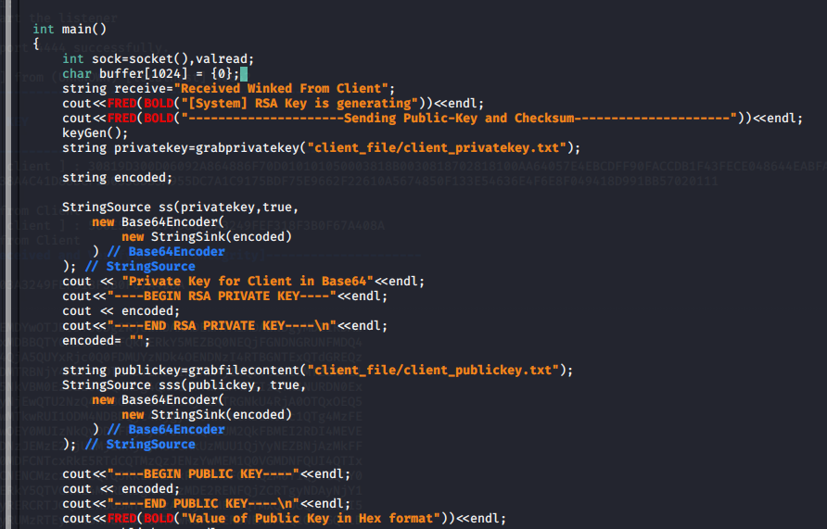

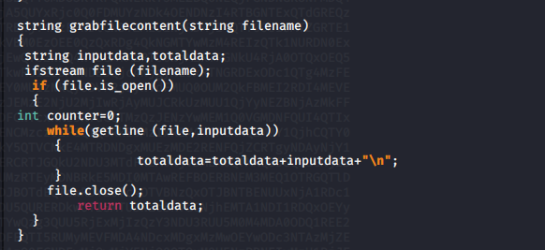String grabprivatekey(), which will return us the content of the file string grabfilecontent

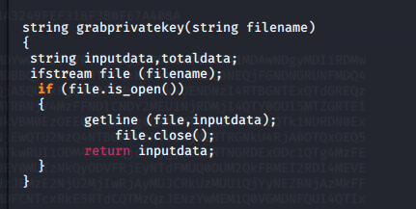

Difference between these two is ‘\n’.

Take a look on client’s socket()

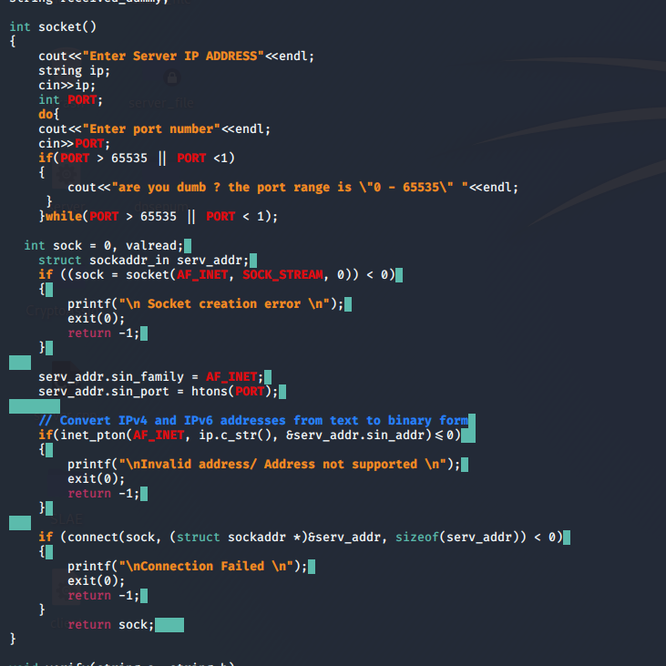

After we start finished executing our client and *ENTER* we able to see that server and client has *successfully established the connection.* From the server perspective we can see that ***we got a connection from (UNKNOWN) localhost from source port 40842.***

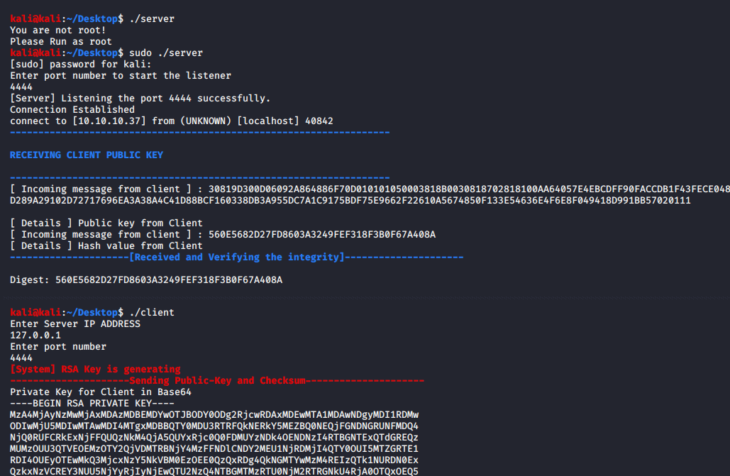

After both of them has successfully establish the connection, their directory will store a few .txt which contain their own keys and sender’s publickey in *HEX format.*

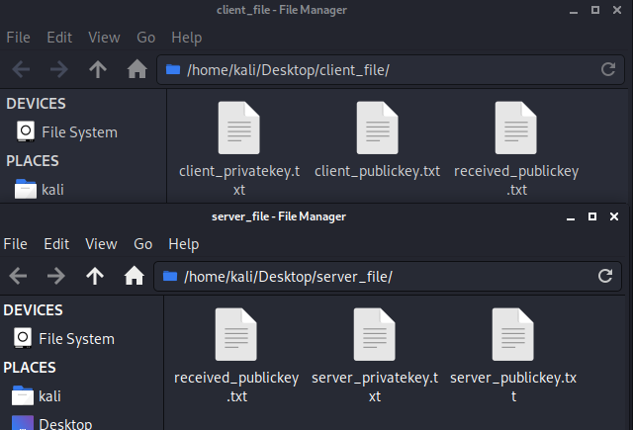

Client (Bob) sends his **public key y2** to Host (Alice) together with Hash of this key in SHA-1 format.

Client is ready and listens to the port for next response.

We now will send the publickey and it digest to Server over the network.

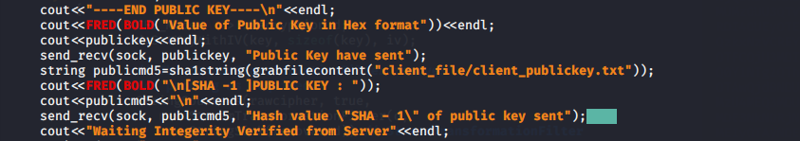

We will take grab the content of publickey from the ‘*client_file/client_publickey.txt*’ using the grabfilecontent function and go into *sha1string* function

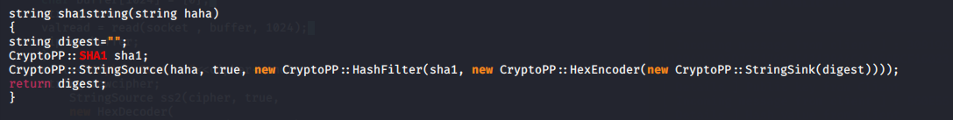

The value will be return and store into a variable named “publicmd5”, we take this both value ‘publickey’ and ‘sha1 digest’ go into send_recv function.

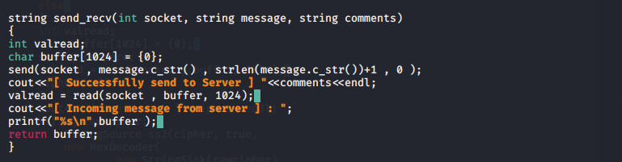

This *send_recv* function will be sending message 1st and receive message after finish sending messages over the network.

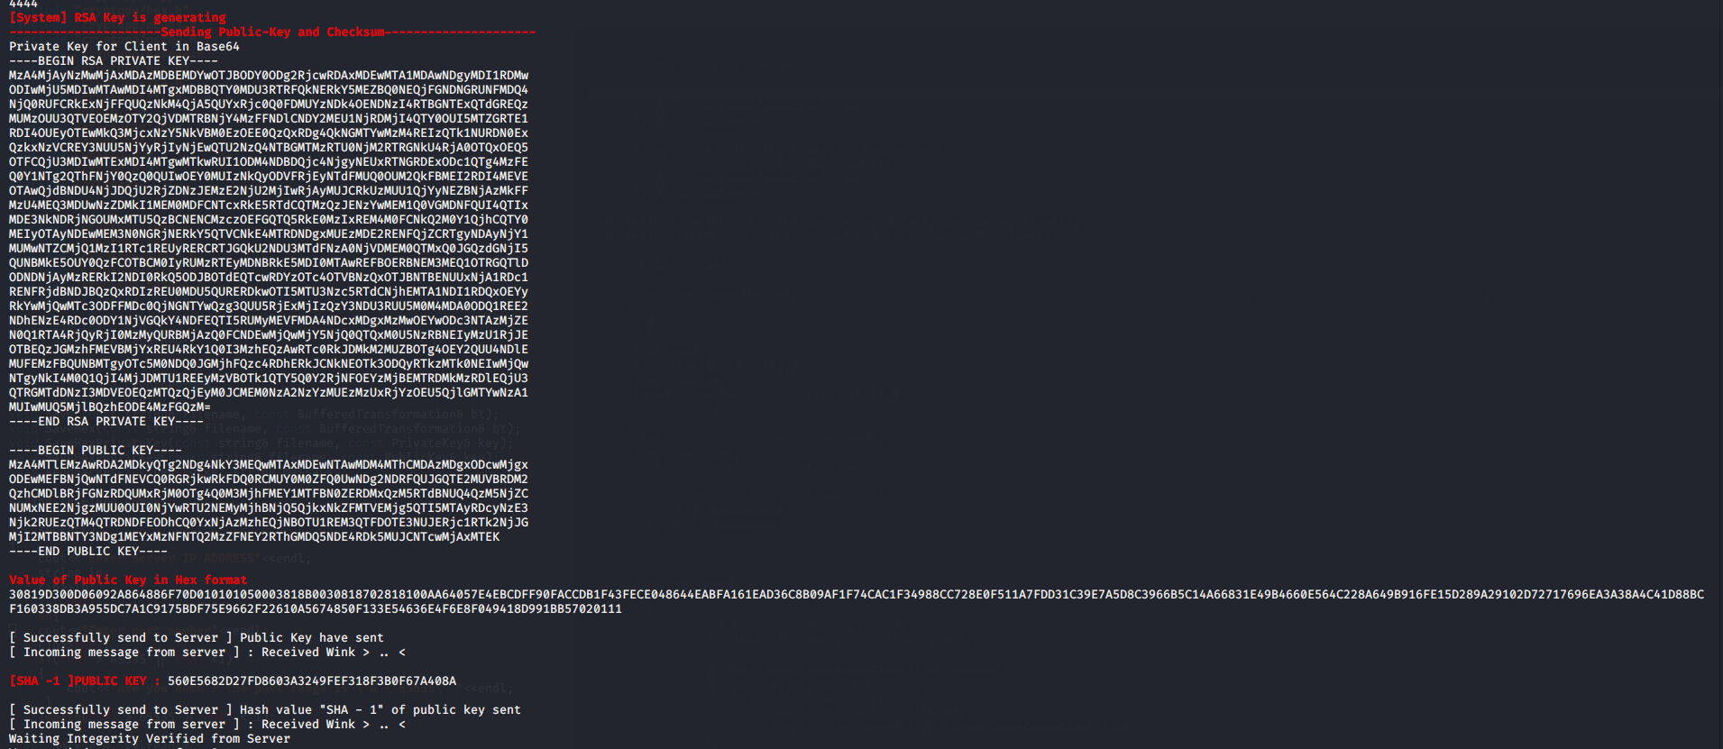

# Upon receiving the public key and SHA-1 hash from Bob, Alice first verify the integrity of the Public key. Alice then send a “Verified” message to Bob.

Now ‘Alice == Server’ will be receiving ‘PublicKey’ and ‘it digest’ value from Client.

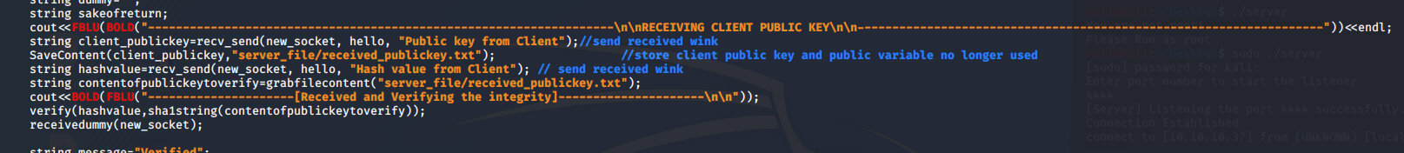

Next it will run ‘*recv_send*’ function

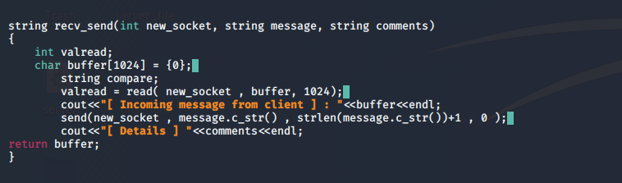

It mainly receive message from opponent/Client and response back to Server. The response message is “*Received Wink > .. <*”  
After received both messages (PublicKey and Hash) from Client, we will run a *comparison* to making sure the ‘*value of digest that we received from client*’ is matched with (“*the publickey received and hash it*”)

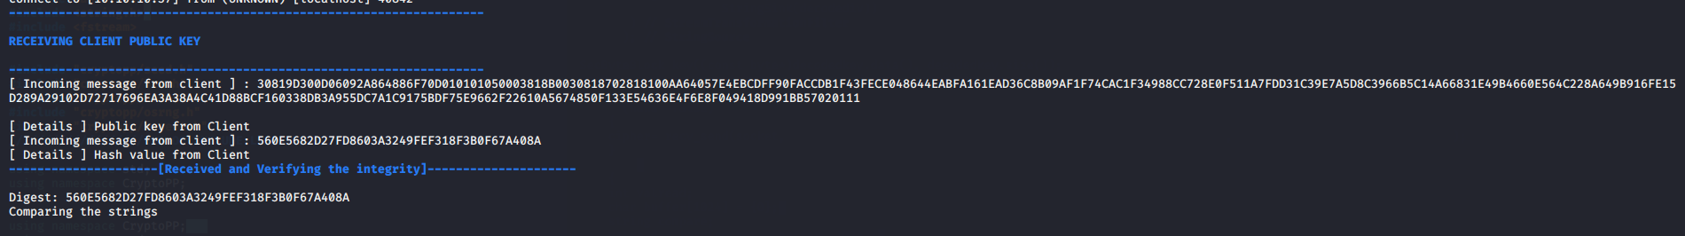

After finished the verify function,

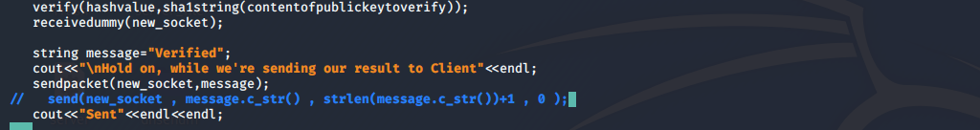

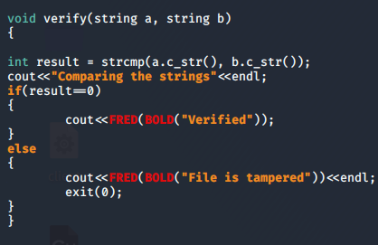  
If it’s matched, it will go into receiveddummy(new_socket) function which is just to received message or dummy message from Client because in socket programming it have to be “**Send and Received**” and cannot be “**Send Send and Recieved**”. **Else program quit.**

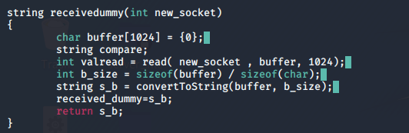

After,we have received *dummy_messages* from Client, we will send Verified message over network to Client.

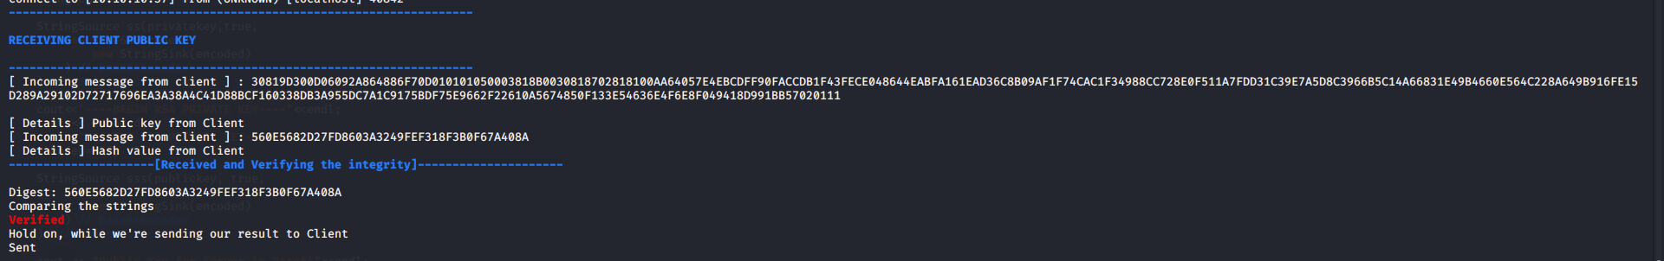

Client perspective, it state that they received a response from Server and if it’s matched then Continue to compare the strings else the program will quit.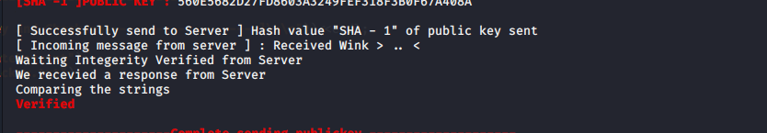

# Alice then computes/generates the **192 bit AES session key and SHA-1 hash of this session key**. This session key is unique for each runs of the program.

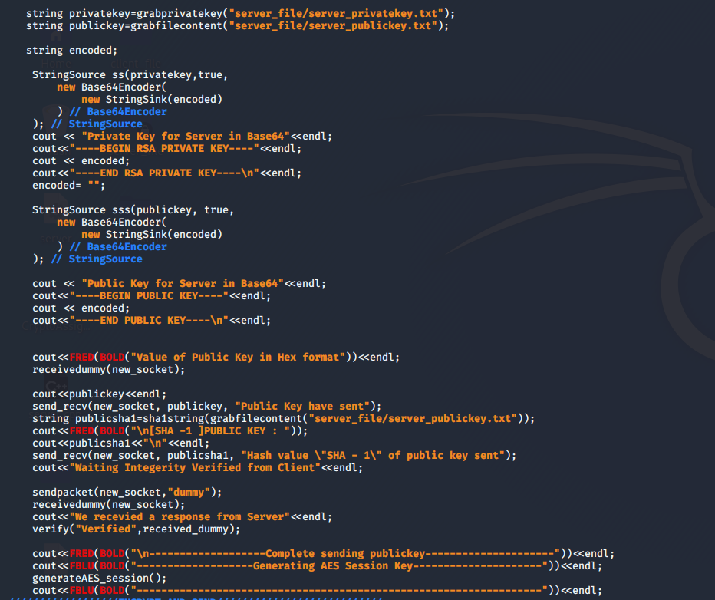

After finished executing server’s previous code, we reach to extract our publickey and privatekey from “*server_file/server_publickey.txt*” & “*server_file/server_privatekey.txt*” into 2 different variables, same as Client, we encode it into Base64 just for “**Display purpose**” and we will received dummy packet from receivedummy() function, as I mentioned previously “*the structure of socket programming, send and received*”.  
Then we will run “send_recv()” function to send Server’s publickey and hashes over the network to Client.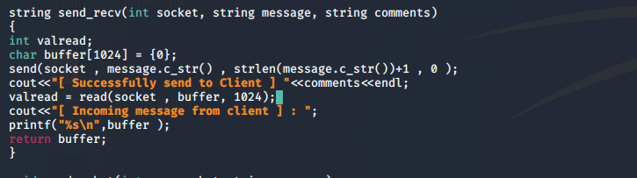

Which is send message over network and received response from Client.

After finished the sending process  
We will jump to generate “AES Key” in *generateAES_session()*

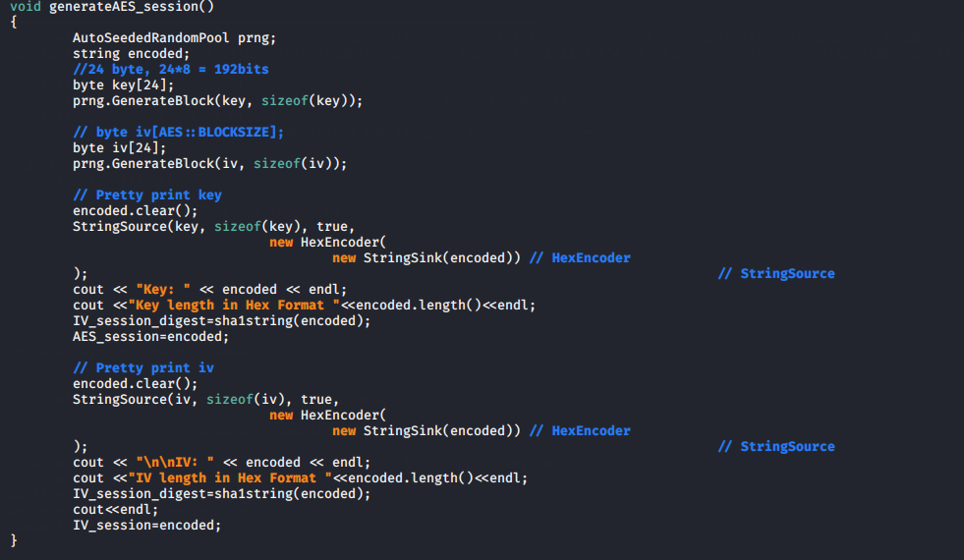*Take note* , IV_session and AES_session are **global variable, I will attach all the relevant library and global variable at the end of section.** After finish executed the generateAES_session(), the AES KEY and IV are store in IV_session and AES_session variables.

# Alice sends her public key y1 + SHA-1 hash to Bob (Client) – expose. Then she send encrypted 192 bit AES session key + SHA-1 hash with Bob Public Key y2.

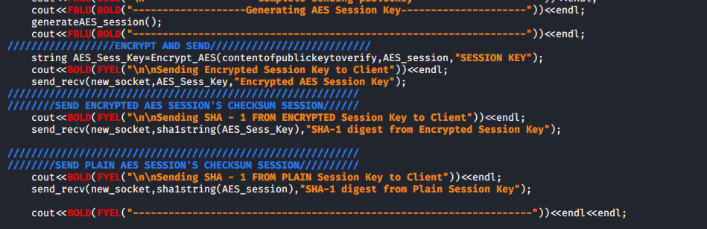After we get the value of “KEY” and “IV” We will encrypting our KEY using Encrypt_AES(), which using Client’s public key to run the encryption process on the “AES KEY” which we get a ‘cipher text’ which is encryptedkey. We will be sending 3 type of content over network

1.Encrypted AES Key X + K = Y

2.Hash of Encrypted AES Key H(Y)

3.Hash of AES Key H(P)

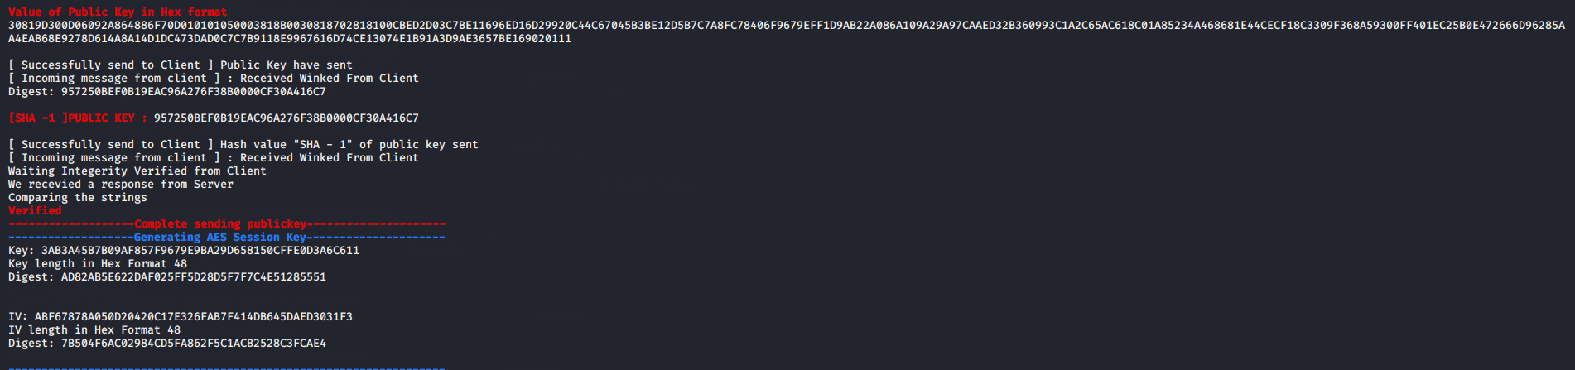

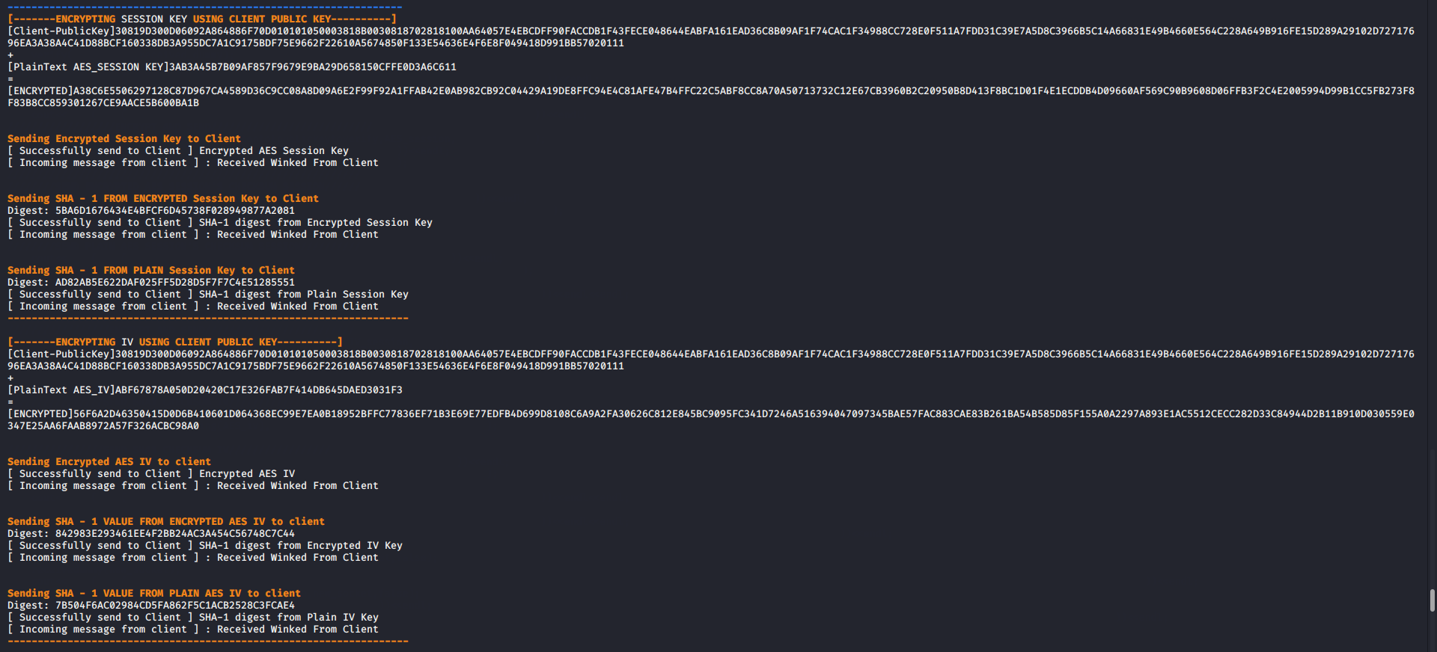

# Bob received the above components. He verify Alice public key y1 with the SHA-1 hash.

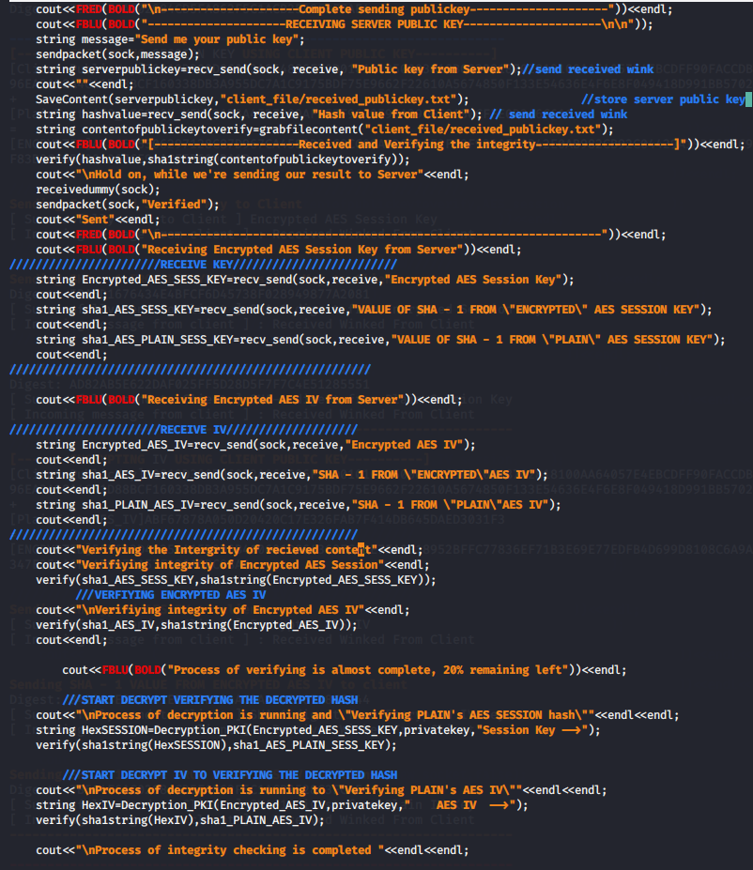  
After finished the process of sending Client’s Public_Key to Server, run a function called “SaveContent()” to store the “Server’s Public key” into a text file at “*client_file/received_publickey.txt*”.

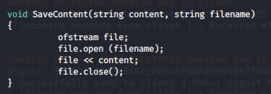

Then we will received the publickey’s hashes, next will grabthecontent of the publickey from the textfile.   
Run a *verify()* function

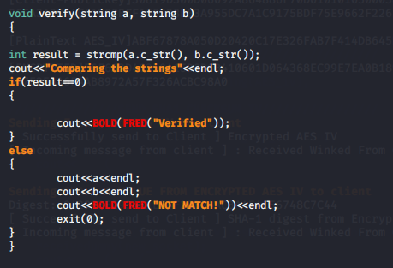

After finished the verifying process, we will be receivedummy() as I mentioned previously “*structure of socket programming*”.  
Then we will send a response to Server tell to Server that Client has successfully received and verified successfully the hashes with it encrypted key and it hashes.

# Then Bob decrypt the encrypted components of 192 bit AES session key + SHA-1 hash using **his Private Key x2**.

Assume that Client has successfully verify the *Encrypted Key* with *Hash from Encrypted Key*  && the *Encrypted IV* with *Hash from Encrypted IV*  
Keys HASH  
Y ✓ Y ✓  
H(Y) ✓ H(Y) ✓  
H(X) ? H(X) ?  
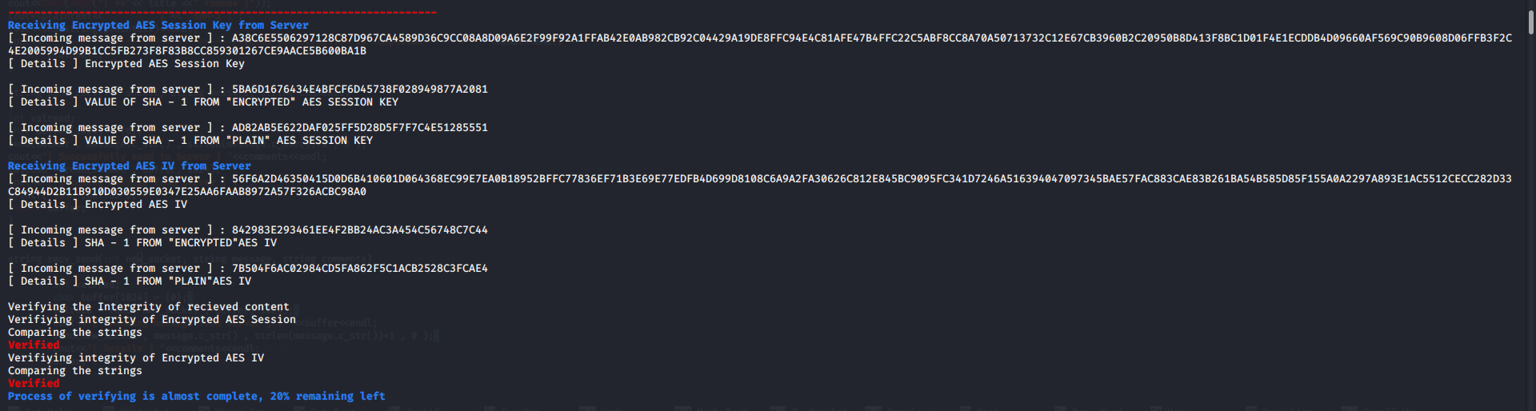Hold on, we have not verify the HASH that came from plaintext. But we only have encrypted content so we need to run decryption on the encrypted content and take the decrypted content to hash it and compare with H(X).

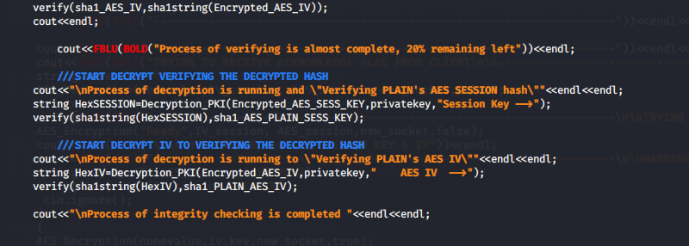

We have a look at *Decryption_PKI(),* that will be decrypt our encrypted content and bring the decrypted content into hash and verify.

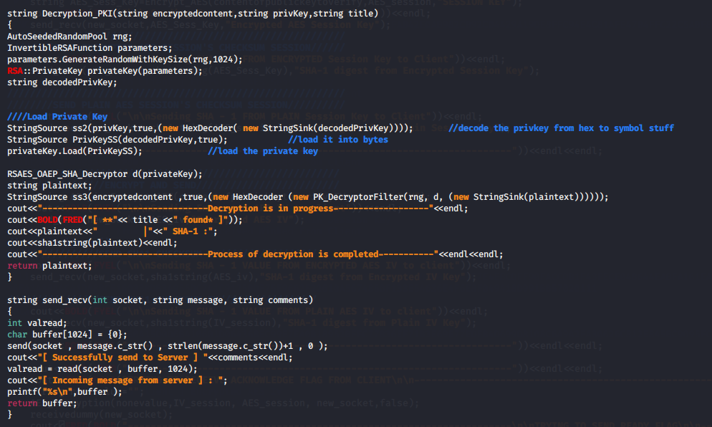

It will take the “HexEncoded PrivateKey” run HexDecoder into raw and load into privatekey and decrypt on the encrypted content   
(“it can be KEY or IV”), It will go into HexDecoder first and only start the PK_DecryptorFiltering decryption and DONE, we have our plaintext.

**Assume, everything went GOOD.**

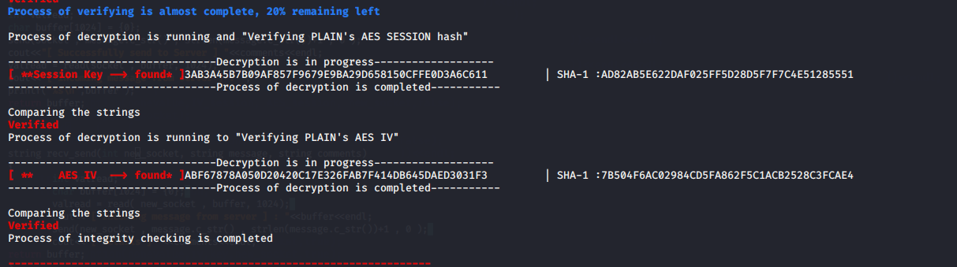

# As for confirmation of receiving the session key, Bob encrypt back a message of “Acknowledge” with the **192 bit AES session key** and send back to Alice. (note: only when step 8 and 9 above are verified with their respective Hash).



We declare a variable with “NULL” value inside.  
Client will run an AES_Encryption using the “AES_IV” and “AES_KEY” that decrypt from the Encrypted IV and Encrypted Key that send from “Server”.

***\*Due to code too long, unable to screenshot. I have pasted it here as text format\****

void AES_Encryption(string temp, string AESiv, string AESkey,int socket,bool haha)

{

string plain;

if(haha==false)

{

plain = temp;

}

else

{

do

{

cout<<"Enter message send to server"<<endl;

std::getline(std::cin, plain);

if(plain.size()>1024)

{

cout<<BOLD(FRED("Message is exceed the length"))<<endl;

}

}while(plain.size()>1024);

}

string recovered;

AutoSeededRandomPool prng;

string decodedkey,decodediv;

StringSource s(AESkey, true,(new HexDecoder(

new StringSink(decodedkey))

) // StreamTransformationFilter

); // StringSource

StringSource ss(AESiv, true,(new HexDecoder(

new StringSink(decodediv))

) // StreamTransformationFilter

); // StringSource

SecByteBlock key((const byte*)decodedkey.data(), decodedkey.size());

SecByteBlock iv((const byte*)decodediv.data(), decodediv.size());

string cipher,encoded;

/*********************************\

\*********************************/

try

{

cout << "plain text: " << plain << endl;

CFB_Mode<AES>::Encryption e;

e.SetKeyWithIV(key, sizeof(key), iv);

// CFB mode must not use padding. Specifying

// a scheme will result in an exception

StringSource(plain, true,

new StreamTransformationFilter(e,

new StringSink(cipher)) // StreamTransformationFilter

); // StringSource

}

catch (const CryptoPP::Exception &e)

{

cerr << e.what() << endl;

exit(1);

}

/*********************************\

\*********************************/

// Pretty print

encoded.clear();

StringSource(cipher, true,

new HexEncoder( new StringSink(encoded)

) // HexEncoder

); // StringSource

cout << "cipher text: " << encoded << endl;

cout<<"encoded length:" << encoded.length()<<endl;

if(haha==false)

{

send_recv(socket,encoded , "Client send \"Received\" to Server");

}

else

{

sendpacket(socket,encoded);

}

if(plain=="quit")

{

cout<<FRED(BOLD("PROGRAM TERMINAL GRACEFULLY"))<<endl;

exit(1);

}

}

Under the *AES_Encryption()*

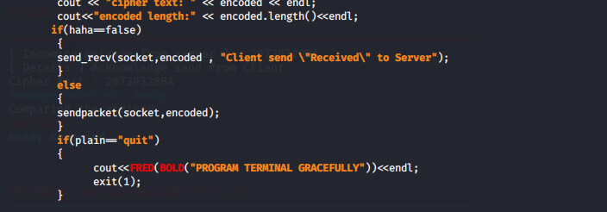



If haha == false, we will run “send_recv” function which we will send “Encrypted Acknowledge text ” over network,   
at here, the variable haha is Boolean type, if false meaning this is before 3 way handshake , if it’s true meaning it’s after establish 3way handshake. We just want to reuse back the function.

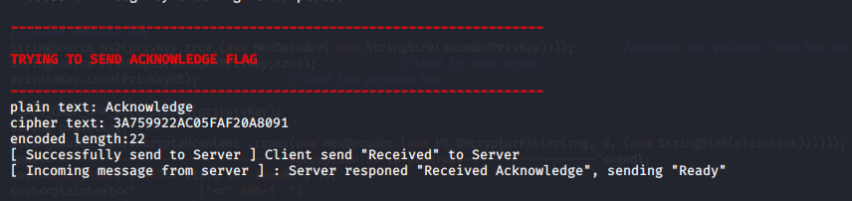

# Upon receiving the encrypted message, Alice Decrypt it (using **her local copy of 192 bit AES session key).** If the message represent **“Acknowledge”** she knows that the secure communication now can take place. If match, Alice send a signal message “Ready” encrypted using the AES session key to Bob.



After received “Encrypted Acknowledge” from Client, Server will take the encrypted go into process of *AES_Decryption()* to find out what is the decrypted text.

***\*Due to code too long, unable to screenshot. I have pasted it here as text format\****

*AES_Decryption()*

*string AES_Decryption(string cipher,string AESiv,string AESkey, int socket,bool haha)*

*{*

*AutoSeededRandomPool prng;*

*string decodedkey,decodediv;*

*StringSource s(AESkey, true,(new HexDecoder(*

*new StringSink(decodedkey))*

*) // StreamTransformationFilter*

*); // StringSource*

*StringSource ss(AESiv, true,(new HexDecoder(*

*new StringSink(decodediv))*

*) // StreamTransformationFilter*

*); // StringSource*

*SecByteBlock key((const byte*)decodedkey.data(), decodedkey.size());*

*SecByteBlock iv((const byte*)decodediv.data(), decodediv.size());*

*if(haha==false)*

*{*

*cipher= recv_send(socket, "Server responed \"Received Acknowledge\", sending \"Ready\"", "Acknowledge send from Client");*

*}*

*else*

*{*

*int valread;*

*char buffer[1024] = {0};*

*string compare;*

*valread = read(socket , buffer, 1024);*

*cipher=buffer;*

*}*

*cout<<"Cipher Text : "<<cipher<<endl;*

*string rawcipher;*

*StringSource ss2(cipher, true,*

*new HexDecoder(*

*new StringSink(rawcipher)*

*) // HexEncoder*

*); // StringSource*

*string recovered;*

*try*

*{*

*CFB_Mode<AES>::Decryption d;*

*d.SetKeyWithIV(key, sizeof(key), iv);*

*// The StreamTransformationFilter removes*

*// padding as required.*

*StringSource s(rawcipher, true,*

*new StreamTransformationFilter(d,*

*d.SetKeyWithIV(key, sizeof(key), iv);*

*// The StreamTransformationFilter removes*

*// padding as required.*

*StringSource s(rawcipher, true,*

*new StreamTransformationFilter(d,*

*new StringSink(recovered)) // StreamTransformationFilter*

*);*

*cout <<FCYN(BOLD("Message Received: " << recovered <<""<<))<<endl;*

*if(recovered=="quit")*

*{*

*cout<<FRED(BOLD("PROGRAM TERMINAL GRACEFULLY"))<<endl;*

*exit(1);*

*}*

*}*

*catch (const CryptoPP::Exception &e)*

*{*

*cerr << e.what() << endl;*

*exit(1);*

*}*

*/**********************************

*\*********************************/*

*if(haha==false)*

*{*

*verify("Acknowledge",recovered);*

*cout<<FGRN(BOLD("\nAcknowledge Recevied\n\n"))<<endl;*

*}*

*return recovered;*

*}*

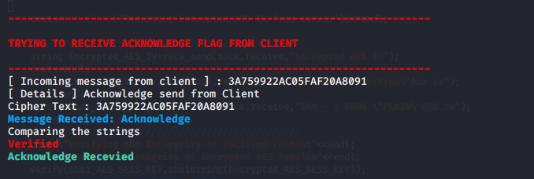

After, we received the decrypted content, we will receive dummy packet again, so we can start the send function.  
We now can start to encrypt ‘Ready’ text and send over network.

*void AES_Encryption(string temp, string AESiv, string AESkey,int socket,bool haha)*

*{*

*string plain;*

*if(haha==false)*

*{*

*plain = temp;*

*}*

*else*

*{*

*do*

*{*

*cout<<"Enter message send to server"<<endl;*

*std::getline(std::cin, plain);*

*if(plain.size()>1024)*

*{*

*cout<<BOLD(FRED("Message is exceed the length"))<<endl;*

*}*

*}while(plain.size()>1024);*

*}*

*string recovered;*

*AutoSeededRandomPool prng;*

*string decodedkey,decodediv;*

*StringSource s(AESkey, true,(new HexDecoder(*

*new StringSink(decodedkey))*

*) // StreamTransformationFilter*

*); // StringSource*

*StringSource ss(AESiv, true,(new HexDecoder(*

*new StringSink(decodediv))*

*) // StreamTransformationFilter*

*); // StringSource*

*SecByteBlock key((const byte*)decodedkey.data(), decodedkey.size());*

*SecByteBlock iv((const byte*)decodediv.data(), decodediv.size());*

*string cipher,encoded;*

*/**********************************

*\*********************************/*

*try*

*{*

*cout << "plain text: " << plain << endl;*

*CFB_Mode<AES>::Encryption e;*

*e.SetKeyWithIV(key, sizeof(key), iv);*

*// CFB mode must not use padding. Specifying*

*// a scheme will result in an exception*

*StringSource(plain, true,*

*new StreamTransformationFilter(e,*

*new StringSink(cipher)) // StreamTransformationFilter*

*); // StringSource*

*}*

*catch (const CryptoPP::Exception &e)*

*{*

*cerr << e.what() << endl;*

*exit(1);*

*}*

*/**********************************

*\*********************************/*

*// Pretty print*

*encoded.clear();*

*StringSource(cipher, true,*

*new HexEncoder( new StringSink(encoded)*

*) // HexEncoder*

*); // StringSource*

*cout << "cipher text: " << encoded << endl;*

*cout<<"encoded length:" << encoded.length()<<endl;*

*if(haha==false)*

*{*

*send_recv(socket,encoded , "Server send \"Ready\" message to Client");*

*}*

*else*

*{*

*sendpacket(socket,encoded);*

*}*

*if(plain=="quit")*

*{*

*cout<<FRED(BOLD("PROGRAM TERMINAL GRACEFULLY"))<<endl;*

*exit(1);*

*}*

*}*

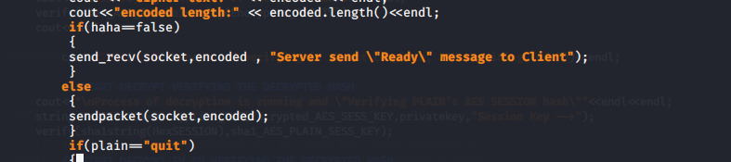

Code above is segment of code in *AES_Encryption() ,* if we found out the variable *haha* is “*false*”, we will send_recv packet the encoded content over  
We go back to our *int main()* we can clearly see that the 5th parameter is “False”



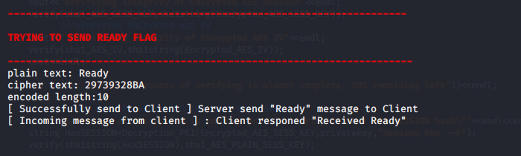

# Once the message “Ready” sent to Bob, Alice reverse the 192 bit AES key to be use for the next secured communication.

We now take a look on *AES_Decryption()*

***\*Due to code too long, unable to screenshot. I have pasted it here as text format\****

*string AES_Decryption(string cipher,string AESiv,string AESkey, int socket,bool haha)*

*{*

*AutoSeededRandomPool prng;*

*string decodedkey,decodediv;*

*StringSource s(AESkey, true,(new HexDecoder(*

*new StringSink(decodedkey))*

*) // StreamTransformationFilter*

*); // StringSource if(haha==false)*

*StringSource ss(AESiv, true,(new HexDecoder(*

*new StringSink(decodediv))*

*) // StreamTransformationFilter*

*); // StringSource*

*SecByteBlock key((const byte*)decodedkey.data(), decodedkey.size());*

*SecByteBlock iv((const byte*)decodediv.data(), decodediv.size());*

*if(haha==false)*

*{*

*cipher=recv_send(socket,"Client responed \"Received Ready\"", "Acknowledge send from Client");*

*// sendpacket(socket,"Client responed \"Received Ready\"");*

*}*

*else*

*{*

*int valread;*

*char buffer[1024] = {0};*

*string compare;*

*valread = read(socket , buffer, 1024);*

*cipher=buffer;*

*}*

*cout<<"Cipher Text : "<<cipher<<endl;*

*string rawcipher;*

*StringSource ss2(cipher, true,*

*new HexDecoder(*

*new StringSink(rawcipher)*

*) // HexEncoder*

*); // StringSource*

*string recovered;*

*try*

*{*

*CFB_Mode<AES>::Decryption d;*

*d.SetKeyWithIV(key, sizeof(key), iv);*

*// The StreamTransformationFilter removes*

*// padding as required.*

*StringSource s(rawcipher, true,*

*new StreamTransformationFilter(d,*

*new StringSink(recovered)) // StreamTransformationFilter*

*);*

*cout << FCYN(BOLD("Message Received: " << recovered<<""))<< endl;*

*if(recovered=="quit")*

*{*

*cout<<FRED(BOLD("PROGRAM TERMINAL GRACEFULLY"))<<endl;*

*exit(1);*

*}*

*}*

*catch (const CryptoPP::Exception &e)*

*{*

*cerr << e.what() << endl;*

*exit(1);*

*}*

*/**********************************

*\*********************************/*

*if(haha==false)*

*{*

*verify("Ready",recovered);*

*cout<<FGRN(BOLD("\nReady Recevied"))<<endl;*

*}*

*return recovered;*

*}*

Inside the *AES_Decryption()*, it have a function what will ‘*received encrypted message that sent from Server*’.

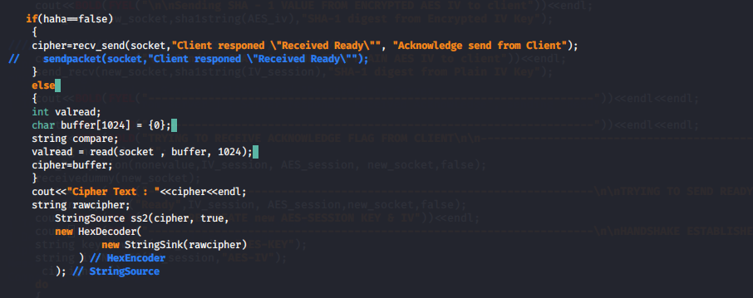

Same, if (haha == true) will run send_recv function. Else will only run “Recv function”



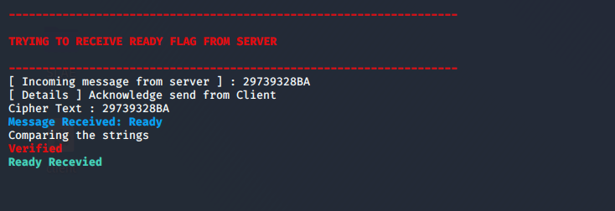

# Bob, upon receiving this Encrypted message “Ready”, he decrypts it and identifies this signal. With this, Bob now, reverse the 192 bit AES key.



After finish the Decryption, the HANDSHAKE is *establish,* we will run another function which will reverse the key.

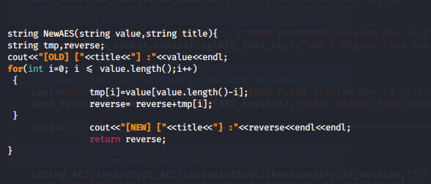

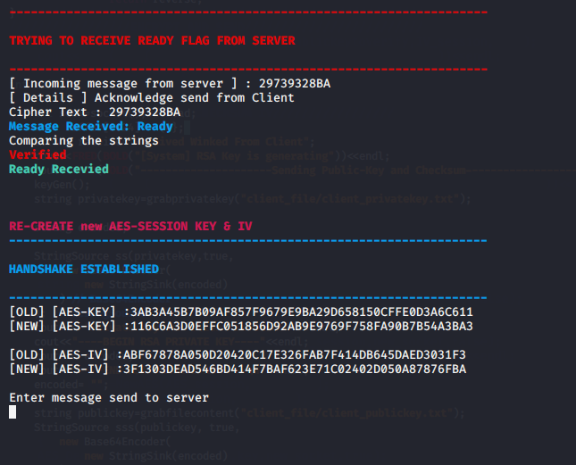

# Now, the secure channel is established.

## Either Alice or Bob can send a message encrypted with the **reverse** **192 bit AES session key** (from the original key) now. They type the message on their own terminal. The message is encrypted by the program (Host or Client) and sent out.

## All message must use Cipher Feed Back Mode (CFB) mode of block Cipher.

## The received encrypted message and decrypted message are displayed on the screen.

## Either one Host or Client can quit the program by using “exit”.

On Server side, Alice will have to reverse the IV and the KEY too.



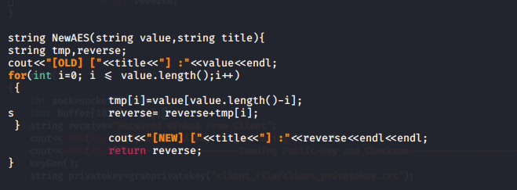

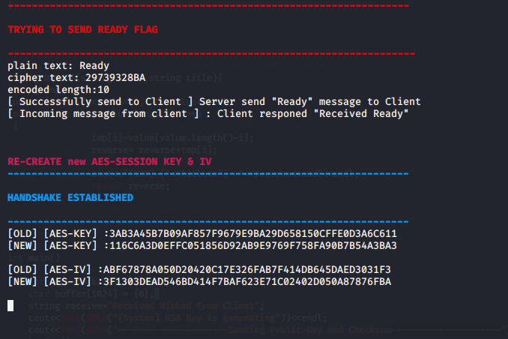

**Before Communication Established**

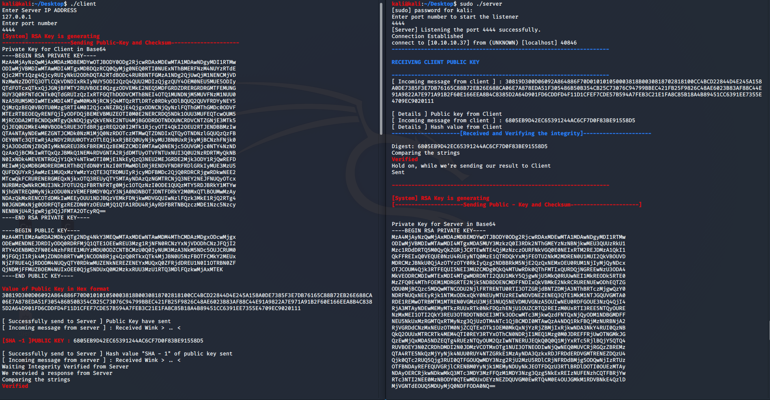

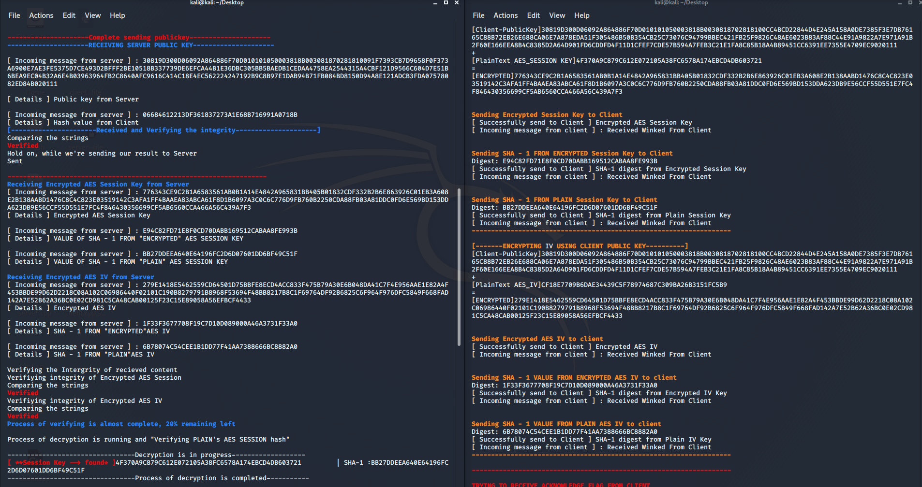

**Key Reversing + sending text ready to pair.**

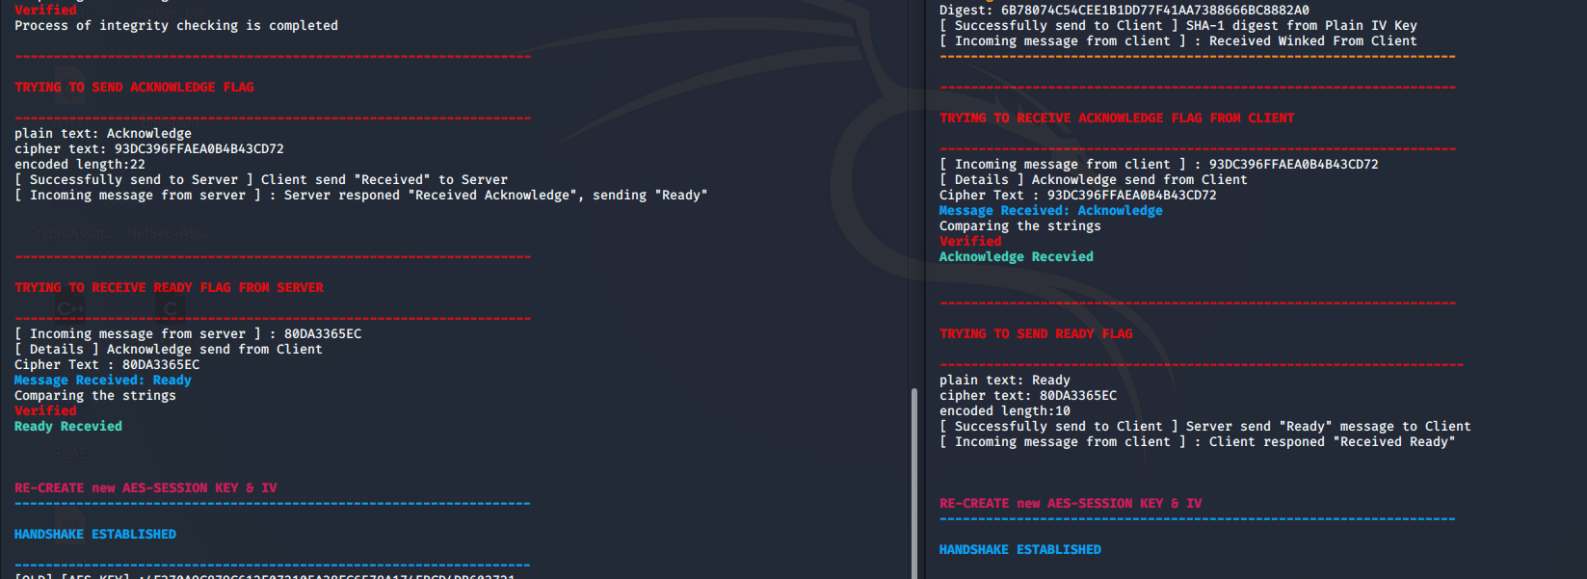

**After Communication Established**

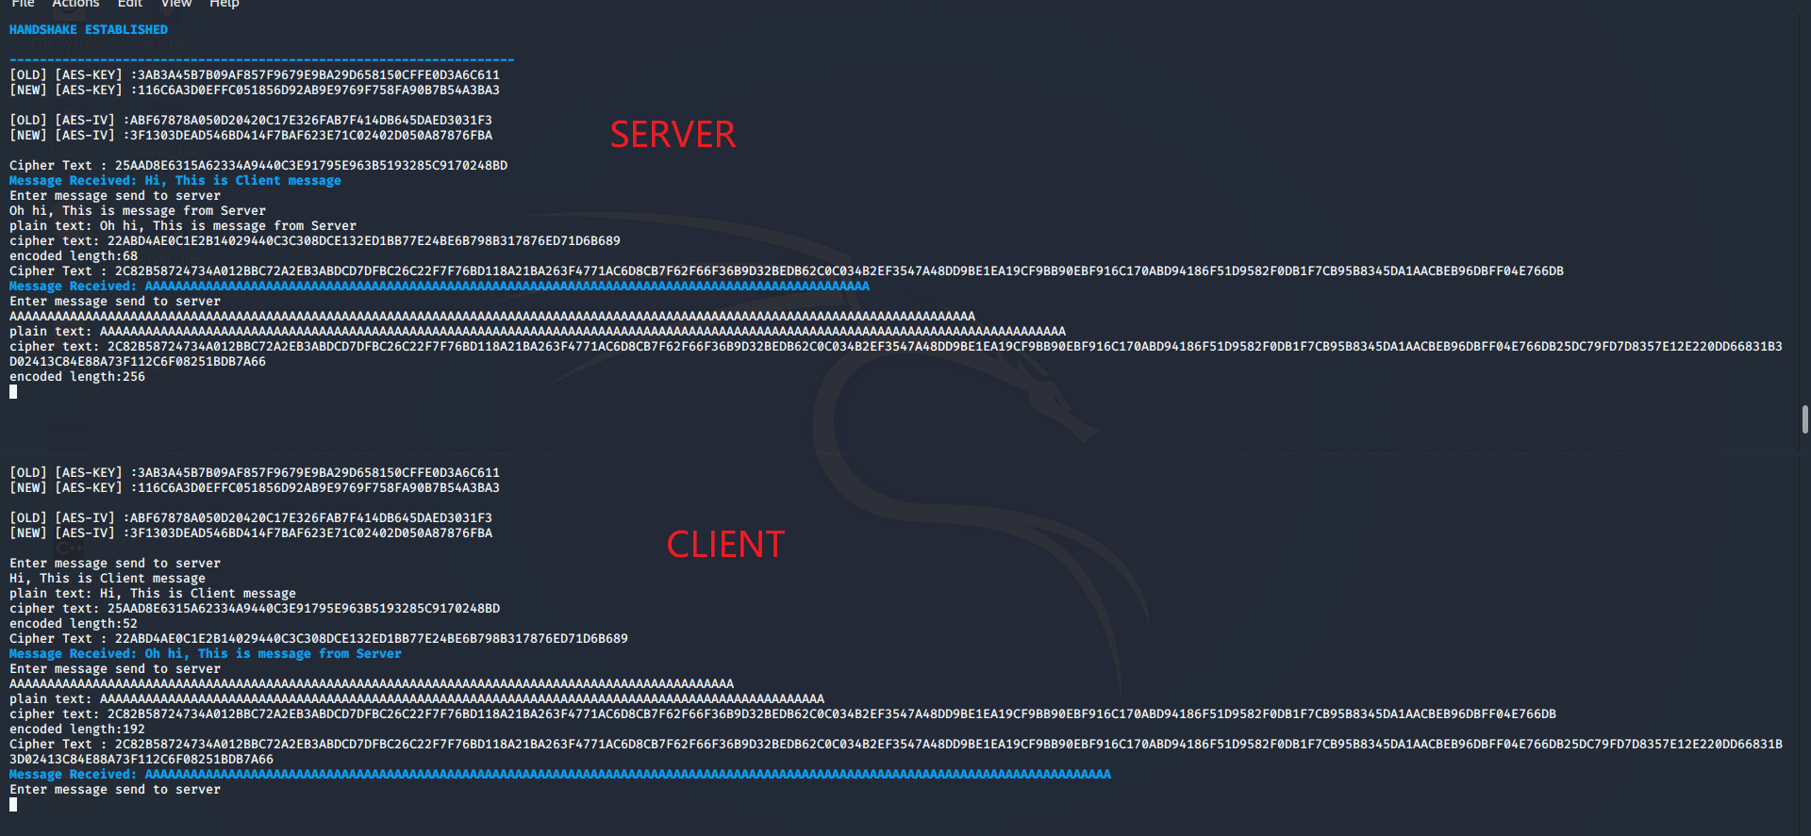

# **USER MANUAL (GITHUB)**

## README.MD

README.MD

## GIT CLONE FROM GITHUB

To download the program in Ubuntu or Linux environment

kali@kali:~/Desktop$ git clone https://github.com/Applebois/NetSec-Assignment1

Cloning into 'NetSec-Assignment1'...

remote: Enumerating objects: 19, done.

remote: Counting objects: 100% (19/19), done.

remote: Compressing objects: 100% (12/12), done.

remote: Total 19 (delta 5), reused 19 (delta 5), pack-reused 0

Unpacking objects: 100% (19/19), done.

## INSTALLATION

Install the crypto++ library or else might not able to build/compile in later.

#sudo apt-get update

Then, issue next command to install crypto++

#sudo apt-get install libcrypto++-dev libcrypto++-doc libcrypto++utils

## COMMAND TO COMPILE/BUILD

How to compile the source code after issued “git clone” command

# cd NetSec-Assignment1

# cd Source

# g++ -g3 -ggdb -O0 -Wall -Wextra -Wno-unused -o server server.cpp -lcryptopp

# g++ -g3 -ggdb -O0 -Wall -Wextra -Wno-unused -o client client.cpp -lcryptopp

## ADD PRIVILEGE TO THE BINARY FILE

Change program privilege to allow execution after issued “git clone” command

#chmod u+x server

#chmod u+x client

#./server

You are not root!

Please Run as root

#sudo ./server

[sudo] password for kali:

Enter port number to start the listener

^C

#./client

Enter Server IP ADDRESS

^C